Academic Year: 2025-26 | Year: Second Year | Term: I
Roll No.: 1012411011 | Name: Riddhee Kulkarni
Subject: Java
Assignment No.: 10 | Title: Registration System
Date: 01/10/2025

Aim:
Create a simple GUI application using Swing components like JFrame, JLabel, JTextField, JButton, and ActionListener with event handling. Design a basic interface for any Registration System.
Theory:
Event Handling:
Event handling in Java Swing is the mechanism that allows programs to respond to user interactions such as mouse clicks, key presses, or button actions. Swing follows the **event delegation model**, where the component that generates an event (like a button) is called the **event source**, the class that listens for the event is called the **event listener**, and the information about the event is carried by an **event object** (like `ActionEvent`). For example, when a button is clicked, the button generates an `ActionEvent`, and the `ActionListener`’s `actionPerformed()` method executes the required code. This makes applications interactive and user-friendly.
JFrame:
`JFrame` is the top-level container in Swing that represents the main application window. It provides a space where all other components like labels, text fields, and buttons are placed. You can set its size, layout, title, and closing behavior, and it can hold multiple panels or components to design a complete graphical interface. For example, in a registration form, the `JFrame` acts as the window where all form fields and buttons are displayed.
JLabel:
`JLabel` is a component used to display text, images, or both, but it is non-editable, meaning the user cannot modify its content. Labels are mainly used to describe other components, such as “Name:” or “Password:”, to guide the user about what to enter in a text field. A label can also display results or status messages in a program. For instance, in a login form, a `JLabel` might say “Enter Username” before a text field.
JTextField:
`JTextField` is a Swing component that allows the user to input a single line of editable text. It can be used to enter information such as names, email addresses, or search queries. Developers can set its width (in terms of columns) and retrieve the entered text using the `getText()` method. For example, in a registration form, a `JTextField` would be used for the user to enter their name, and this value can later be validated or processed when a button is clicked.

JButton:
`JButton` is a push button component that triggers an action when clicked by the user. It is often associated with event handling through an `ActionListener`, which specifies what should happen after the button is pressed. For example, when the user clicks a “Submit” button, the program might retrieve the text from a `JTextField` and display it in a message box. Buttons are essential in making the interface interactive, as they serve as the main triggers for events.
Flowchart:
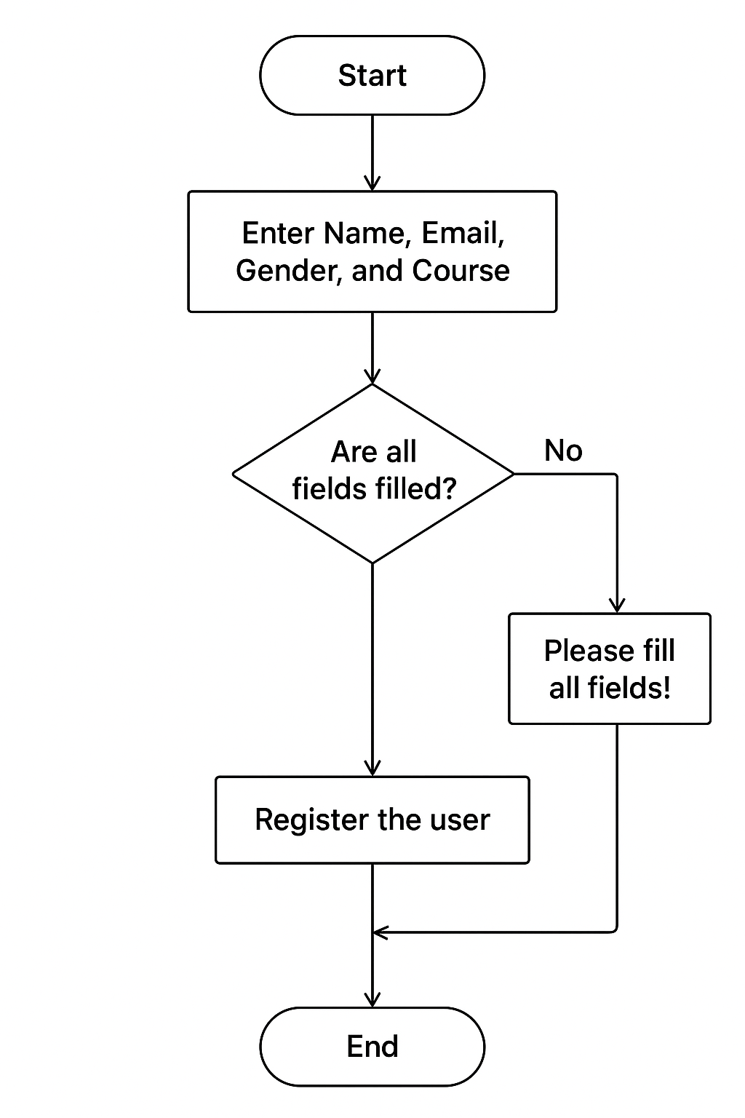
Code:
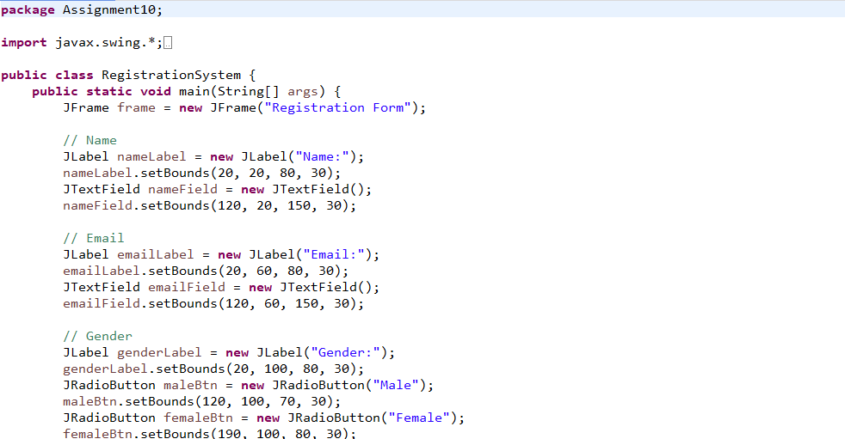
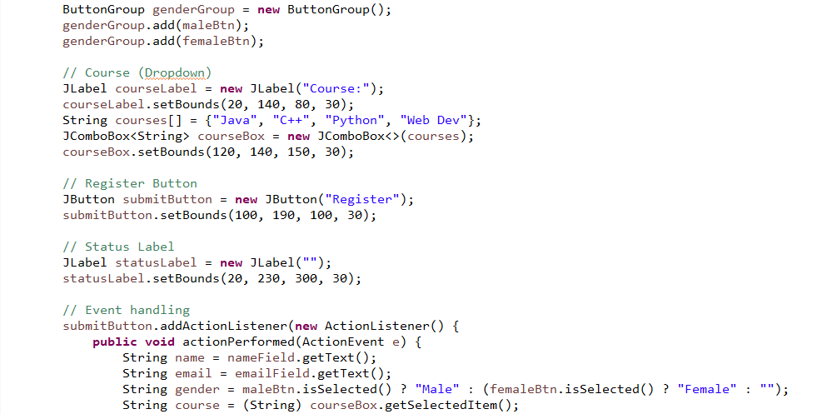
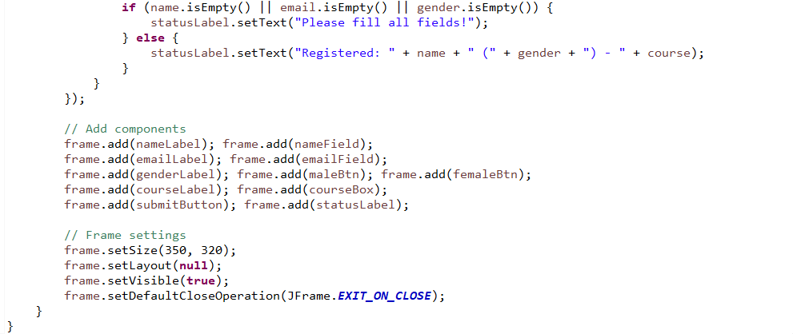

Output:
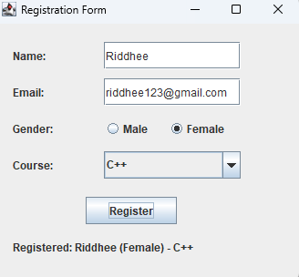

Conclusion: Basic interface for any registration system is designed.

